Why Do World Ecosystems Matter?

Standards:
Statistics and Probability
- 6.SP.1. Recognize a statistical question as one that anticipates variability in the data related to the question and accounts for it in the answers.
- 6.SP.2. Understand that a set of data collected to answer a statistical question has a distribution which can be described by its center, spread, and overall shape.
- 6.SP.4. Display numerical data in plots on a number line, including dot plots, histograms, and box plots.
- 6.SP.5. Summarize numerical data sets in relation to their context, such as by:
  - Reporting the number of observations.
  - Describing the nature of the attribute under investigation, including how it was measured and its units of measurement.
  - Giving quantitative measures of center (median and/or mean) and variability (interquartile range and/or mean absolute deviation), as well as describing any overall pattern and any striking deviations from the overall pattern with reference to the context in which the data were gathered.
  - Relating the choice of measures of center and variability to the shape of the data distribution and the context in which the data were gathered.

Learning Objectives:
- Students will create statistical questions and data charts that represent those statistical questions.

Resources:
- Computer with Internet access

Technology Integration:
Gapminder.com is an amazing resource that provides data for over 300 indicators for every country in the world. It is used in this project to create the data charts and maps.

Why Do World Ecosystems Matter?

You will be using the website, Gapminder.com, that is an excellent resource that provides data about over 300 indicators for all of the countries in the world. The Gapminder World web service lets you visualize and track all countries’ progress on many different measures of health, education and the other indicators. What’s really great is how Gapminder World converts dry numbers into fun, animated, interactive graphs, which show patterns and relationships in stunning ways.

Project Tasks:
- You may select any ecosystem that you have studied (desert, artic tundra, mountains, temperate forests, rainforests, savannah, grasslands, etc.).
- Identify the countries around the world where this ecosystem exists.
- Use Gapminder.com to compare data from these countries. Data to compare could include Population, Imports, Exports, Crops, and any other relevant data.
- Questions could include:
      - Which data indicators are most affected by this ecosystem? Explain.
      - When you compare the countries in this ecosystem for any three data indicators that you select, evaluate inconsistencies in data for these data. Do some of the data not really make sense for this ecosystem? Hypothesize other factors that could be causing these inconsistencies.

Rubric:
Objective | 1  Novice | 2  Apprentice | 3  Proficient | 4  Distinguished
Students will create statistical questions and data charts that represent those statistical questions. | - Much difficulty in selecting an ecosystem of the world  - Incorrectly identified few of the countries that contain that ecosystem  - The question posed is not a statistical question and not really related to the ecosystem  - Much difficulty in selection of data indicators and graph and not related to question  - Discussion very short; not really an interpretation of the chart and data indicators; discussion is not logical  - Product and/or information are not related to the discussion; many grammar/ spelling errors  - No real inconsistencies discussed; no evidence of understanding  - Information used in the discussion is inappropriate, incorrect, and not suited to the specified inconsistency and question | - Needed assistance in selecting an ecosystem of the world  - Identified half of the countries that contain that ecosystem  - Inappropriate statistical question or not related to the ecosystem  - Selection of data indicators and graph are not related to question  - Interpretation of the chart and data indicators are incorrect or not logical  - Product and/or information are inaccurate or not related to the discussion; several grammar/ spelling errors  - 1 inconsistency discussed; poor evidence of understanding  - Information used in the discussion is inappropriate, incorrect, or not suited to the specified inconsistency and question | - Selected an ecosystem of the world  - Correctly identified most countries that contain that ecosystem.  - Appropriate statistical question related to the ecosystem  - Selection of data indicators and graph are relevant, accurate, and specific to question  - Interpretation of the chart and data indicators is logical  - Accurate, product and information; Few grammar/  spelling errors  - 1-2 inconsistencies discussed; evidence of understanding  - Information used in the discussion is appropriate, correct, and suited to the specified inconsistency and question | - Selected an ecosystem of the world  - Correctly identified ALL countries that contain that ecosystem.  - Creative, insightful statistical questions (2-3 questions) related to the ecosystem  - Selection of data indicators and graph are relevant, accurate, and specific to question; used the best possible data indicators  - Interpretation of the chart and data indicators is creative, insightful, logical  - Accurate, in-depth, neat, organized product and information; No grammar/ spelling errors  - More than one inconsistency discussed; several hypotheses presented to explain inconsistency; evidence of deep insight and understanding, well developed ideas, complex  - Information used in the discussion is clear, appropriate, correct, and suited to the specified inconsistency and question  - Accomplished all of the above on the first attempt

Sample Student Work:

Ecosystem = Desert
Countries in the world with a desert: Australia; Northern Africa (Egypt, Niger, Libya, Sudan, Tunisia, etc); Chile; The Middle East (especially Saudi Arabia, Yemen, Iraq, Kuwait and UAE); Mexico; South Africa; Namibia; Somalia; Central Asia (Afghanistan, Turkmenistan, Uzbekistan, etc); United States; China

Statistical Question: How is the percentage of agricultural land related to the total surface area of counties that contain a desert?

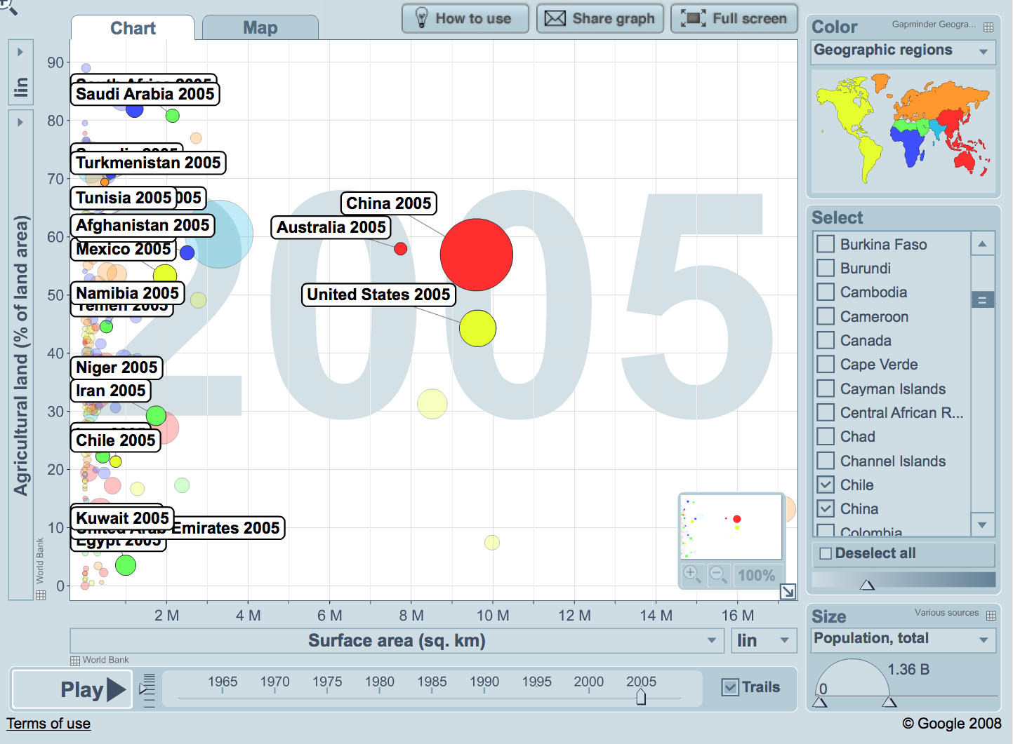
(Click the image to see it on Gapminder.com; you can learn more by clicking Play or Zoom in and out)

Discussion and inconsistencies:
It can be seen from the chart that most countries have less than 4 million sq. km. of total surface area. It would be expected that a desert country would have little agricultural land as you see in Egypt, UAE, Kuwait, and Libya. However, all but 8 of the countries listed above have more than 45% agricultural land. Therefore, it can be concluded that not all of the country is desert (has another ecosystem in the country that can be farmed) or the country has learned ways to develop the desert land into agricultural land.

Statistical question: How is the percentage of agricultural land related to the percentage of money made on agriculture to the total Gross Domestic Product (GDP)?

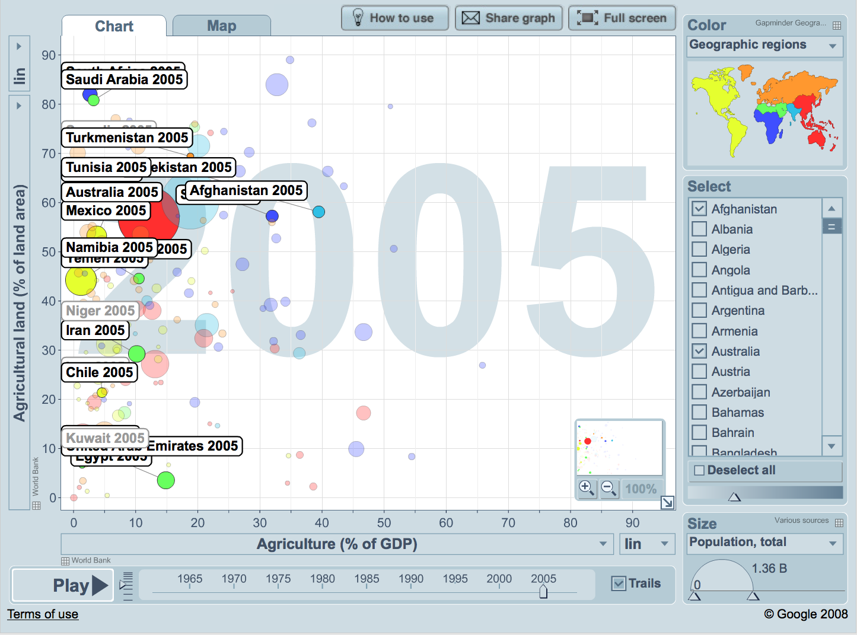
(Click the image to see it on Gapminder.com; you can learn more by clicking Play or Zoom in and out)

Discussion and inconsistencies: In only four countries does agriculture contribute more than 15% to the GDP: Afghanistan 39%, Sudan 32%, Uzbekistan 28%, and Turkmenistan 19%. Therefore, even in countries that have higher percentage of agricultural land, agriculture does not contribute much to total GDP. One explanation could be that agriculture sales do not make much money. Food does not bring much money compared to selling wood or manufactured products. The people could be eating the food rather than selling it. There could be environmental conditions that cause damage to the crops. The countries may not know of research that makes crops grow better and faster. These countries are making most of their money in methods other than agriculture.

Map of these countries:
