Bakin’ in the Sun: Engineering a Solar Oven

Grade Level
Bakin’ in the Sun: Engineering a Solar Oven is an excellent engineering project for any middle grades (sixth through eighth) science classroom.

Learning Objectives
- Students will be able to design and construct an efficient solar oven.
- Students will be able to modify their solar oven to optimize temperature and calculate its power output.

Standards
Next Generation Science Standards—MS. Energy

MS-PS3-c. Design, construct, and test a device that either minimizes or maximizes thermal energy transfer by conduction, convection, and/or radiation. [Clarification Statement: Example of devices could include an insulated box, a solar cooker, and a Styrofoam cup. Care should be taken with devices that concentrate significant amounts of energy.] [Assessment Boundary: Quantitative measures of thermal energy transfer are not assessed.]
Science and Engineering Practices
Constructing Explanations and Designing Solutions
Constructing explanations and designing solutions in 6-8 builds on K-5 experiences and progresses to include constructing explanations and designing solutions supported by multiple sources of evidence consistent with scientific knowledge, principles, and theories.
- Apply scientific knowledge to design, construct, and test a design of an object, tool, process or system.
Disciplinary Core Ideas
PS3.A Definitions of Energy
Temperature is a measure of the average kinetic energy of particles of matter. The relationship between the temperature and the total energy of a system depends on the types, states, and amounts of matter present.
PS3.B Conservation of Energy and Energy Transfer
Energy is transferred out of hotter regions or objects and into colder ones by the processes of conduction, convection, and radiation.
ETS1.A Defining and Delimiting an Engineering Problem
- The more precisely a design task’s criteria and constraints can be defined, the more likely it is that the designed solution will be successful.
- Specification of constraints includes consideration of scientific principles and other relevant knowledge that is likely to limit possible solutions.
ETS1.B Developing Possible Solutions
- A solution needs to be tested, and then modified on the basis of the test results in order to improve it.
- There are systematic processes for evaluating solutions with respect to how well they meet criteria and constraints of a problem.

Crosscutting Concepts
Energy and Matter
- Energy may take different forms (e.g. energy in fields, thermal energy, energy of motion).
- The transfer of energy can be tracked as energy flows through a designed or natural system.
Common Core State Standards Connections:
ELA/Literacy—
RST.6-8.3 Follow precisely a multistep procedure when carrying out experiments, taking measurements, or performing technical tasks.
Mathematics—
MP.1 Make sense of problems and preserve in solving them.

Project Options
Throughout this project, students will have numerous opportunities to be autonomous during the designing, engineering, and testing process. Students will be able to:
- Research designs, select materials that will be needed, and engineer their own solar oven.
- Document, display, and present their design, data collected, and their solar oven’s power output.

Resources Needed
For the successful completion of this project, students will need various materials (boxes, aluminum foil, glue, duct tape, saran wrap, picture frame glass, measuring devices, etc). However, students will be able to select the materials they will need to engineer their solar oven design. Therefore, as part of this assignment, students will be expected to scavenge for materials or buy them on a budget. This restriction is in place to require students to think critically about materials they could use in order to create an innovative solar oven.

After designing and constructing a solar oven, students will be able to test their projects. Students will need access to digital thermometers in order to record the temperature change over a time interval of sixty minutes. Moreover, students will need to utilize technology (computers, iPads, Data Analysis app, internet, etc.) to research solar oven designs and present their projects.

Bakin’ in the Sun: Engineering a Solar Oven

Project Tasks
Scenario: Yesterday, a terrible thunderstorm traversed through your community. It left several thousand people without power and absolutely no way to prepare meals. The community has been told it could take up to two weeks to repair the damaged power lines. Despite this news, families are proactively brainstorming ways in which they can engineer an oven that utilizes an alternative energy source in order to provide food for their families and the community during this time. They have concluded the best energy source for this project is solar energy and have asked middle school science students to help them.

Goal: Develop a team of two other fellow scientists to research, engineer, and test an innovative and efficient solar oven for the people in your community. Your oven will need to efficiently heat up large amounts of soup or broth in order to provide food for the community until the power is restored. Moreover, they have challenged you to only use scavenged materials found around your home or in your community. If needed, you have a budget of five dollars which you may spend on the project, and all expenses must be reported in your presentation.

Task Outline:
- With your group, brainstorm ideas or features you need to take into consideration or incorporate into you design in order to create an efficient solar oven. Use the following questions to discuss and inspire original ideas; outline answers to these questions in the table below to guide your thinking throughout the engineering process. Think outside the box!
- How can I optimize temperature and power output of my oven?
- What factors will influence the performance of a solar oven?
- How will the sun’s energy be captured and trapped inside of the oven?
- How can the sun’s energy be transferred as a heat source to cook food, and how can I design the oven to concentrate this energy into a specific place?
- What materials can would be excellent for this project and where can they be found? How will these specific materials be helpful in this process?
- What materials are possibly needed to be purchased? Is this a necessity to the overall design and performance of my oven? Why or why not?
- Research solar oven designs and analyze the materials used, the engineering process, and how it works. Select two designs that would be most effective briefly describe them in the appropriate section of the table below.
- Using your knowledge about energy and ideas collected from your research, design a solar oven. Utilize drawings, pictures, scales, measurements, and other pieces of information to communicate your design plan efficiently and effectively. This design plan must be neatly organized and included in your final presentation.
- Begin gathering your materials and construct an efficient solar oven. Be sure to document the process along the way by taking digital pictures (by any technology device approved by the teacher) and developing a procedure on “How to Engineer a Solar Oven.” This will be included in your presentation.
- Using your solar oven, follow the procedures below to test the power of your solar oven.
- Set up your oven, as intended, in order to collect the as much sunlight as possible.
- Measure and record the temperature (in Celsius) of 500 mL water sample. Place the water sample in your oven.
- After 10 minutes, measure and record the temperature (in Celsius) of the soup/broth sample in your data table. Continue to collect data every ten minutes over the course of one hour (60 minutes).
- Using your data, determine the total energy absorbed by the water. Show all of your work and circle your final answer.
- Now, calculate the power output of your solar oven.
- Reflect on the design and power output of your solar oven. Brainstorm ways in which you can collect as much energy as possible to improve your oven in order to optimize temperature and power output. Document these ideas, and improve, adjust, or modify your solar oven design.
- Perform the solar oven test again and record your results in the appropriate section of the table below.
- Utilizing technology (Microsoft PowerPoint, advertisement video, Prezi, student webpage, etc.), prepare a presentation outlining your engineering process. You will present your solar oven design to the community and help them prepare soup for the families without power. Incorporate all of the following components into your presentation:
- Detailed solar oven design plan
- List of materials used for the construction of the solar oven, and cost of the materials if necessary
- Procedure followed to construct the solar oven
- Data tables (for test one and test two)
- One graph to compare time and temperature (include data from both tests on one graph)
- Energy and power calculations for test one and test two (show all calculations)
- Modifications and Conclusions
- What possible factors influenced the performance of the solar oven?
- What modifications or adjustments did you make to the oven before the second test? Why?
- How did these modifications influence the performance of your solar oven?
- What other modifications could be made to the solar oven to optimize temperature and power output?
- During your presentation, demonstrate how your solar oven works by heating up a sample of soup for at least two families of four.

- Brainstorm Ideas and Features
- Possible Solar Oven Designs (include source)
- Our Solar Oven Design and Procedures
- Data
Test # 1 |  | Test # 2
Time (minutes) | Temperature ($℃$) | Time (minutes) | Temperature ($℃$)
0 |  | 0
10 |  | 10
20 |  | 20
30 |  | 30
40 |  | 40
50 |  | 50
60 |  | 60

- Energy and Power Output
- Modifications

 | Significant Revision Needed | Some Revision Needed | Proficient | Exceeds Expectations
Students will be able to design and construct an efficient solar oven. | The learner attempts to design and construct a solar oven. The product does not meet the specifications of the assignment. The solar oven is not efficient and takes more than five minutes to assemble. | The learner designs and constructs a solar oven that meets some of the specifications of the assignment. Some parts of the solar oven are built according to the design plan, collects some light. The learner needs more than two minutes to assemble the solar oven. | The learner designs and constructs a solar oven that meets the specifications of the assignment. Most of the solar oven is built according to the design plan, collects the light, and attempts to concentrate it to the container inside the oven. The learner also assembles the oven in two minutes or less. | The learner designs and constructs a solar oven that meets the specifications of the assignment and built according to the plan. The solar oven collects light efficiently and concentrates it towards the container inside the oven. The learner also can assemble the oven in two minutes or less.
Students will be able to modify their solar oven to optimize temperature and calculate its power output. | After testing the solar oven, the learner does not attempt to minor modifications to the oven to optimize temperature and power output. The learner does not increase power output and does not attempt to calculate it or does so inaccurately. The presentation does not effectively communicate components to the community. | After testing the solar oven, the learner makes a minor modification to the oven to optimize temperature and power output. The learner does not increase the power output and calculates it with several errors. The presentation outlines a few components to community members. | After testing the solar oven, the learner attempts to modify the solar oven to optimize temperature and power output. The learner increases power output by 1-2 watts and is able to calculate this with few or minor errors. The presentation outlines and demonstrates some components to community members. | After testing the solar oven, the learner demonstrates his or her ability to modify the design to optimize temperature and power output. The learner increase power output by 3 watts or more and is able to calculate this correctly. The presentation clearly outlines and demonstrates all components to community members.
Sample Work

Sources for Solar Oven Research
http://solarcooking.org/plans/
http://www.instructables.com/id/Cardboard-and-Duct-tape-Solar-Oven/
http://www.instructables.com/id/Cardboard-Foil-Glue-The-Solar-Funnel-Cooker/
http://www.instructables.com/id/Solar-Cooking-With-A-Cardboard-Oven-10/

Solar Oven Design and Procedures

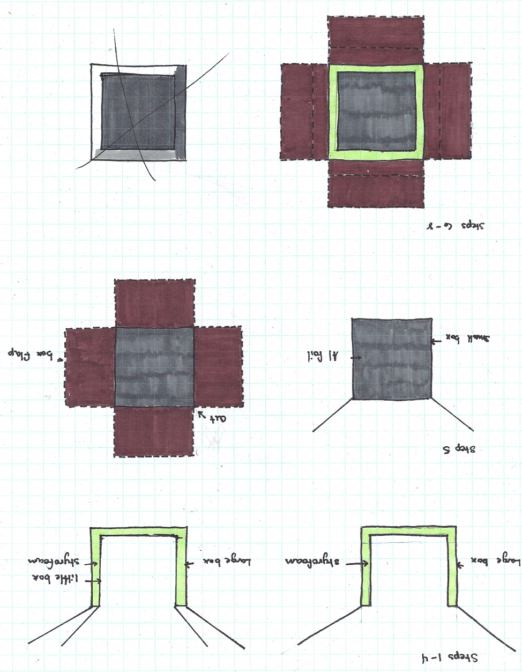
- Remove the small box and line the inside with Aluminum foil. Glue in sections and use a credit card to create a smooth surface. Insert small box inside the large one.
- Fold over large flaps and determine how much is needed to cover the Styrofoam and meet the edge of the small box.
- Cut the excess flaps off.
- Take duct tape and secure the smaller flaps down. Make sure the Styrofoam is covered and the tape is tight and secure.

- Take the small box (with removed flaps) and place inside the large box. Determine the amount of Styrofoam needed to secure the smaller box.
- Cut pieces of 1- ¾” Styrofoam block.
- Place the bottom piece into the box and insert the small box.
- Insulate the sides of the box with the remaining Styrofoam pieces (make sure there is a clean level.

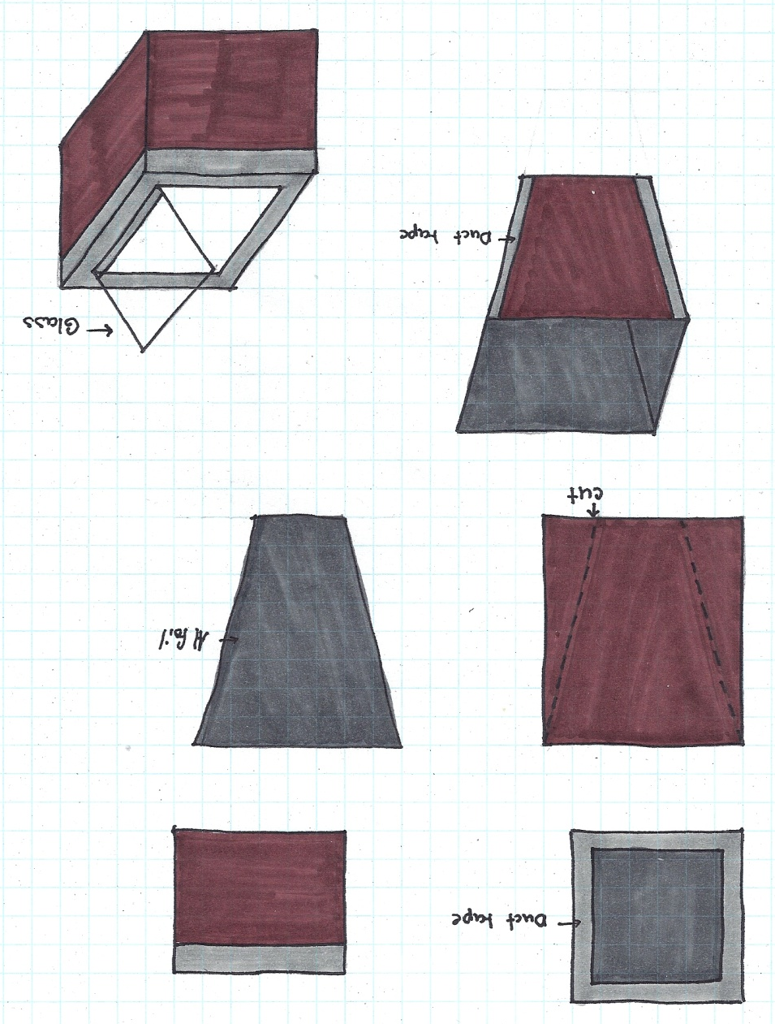
16. Now, place the reflector piece (from step 13) and place on top of the solar oven box.
17. Adjust the reflectors in order to be able to lift the glass up.
18. Tape the reflectors onto the oven box with duct tape.
19. Spray paint a medium-sized metal can black.
20. After the can dries, place it inside the solar oven.
21. Place water sample inside the can and adjust the oven to collect the maximum amount of sunlight.
9. Take a large piece of cardboard to cut four trapezoid reflectors.
10. Create a template and cut reflectors.
11. Using glue and aluminum foil, line the reflectors. Wrap the foil around the backside and secure with duct tape (this should not interfere with the reflective foil because it should be on the outside). Use a credit card to make a smooth clean surface while gluing.
12. Repeat step 11 for all four reflectors.
13. Take strips of duct tape and secure the reflectors together on the outside corners.
14. Take the piece of picture frame glass and place over opening of the small box.
15. Secure the glass on the box along one of the longest sides with duct tape.

Data

Test # 1 |  | Test # 2
Time (minutes) | Temperature ($℃$) | Time (minutes) | Temperature ($℃$)
0 | 23.2 | 0 | 11.3
10 | 32.5 | 10 | 23.0
20 | 35.9 | 20 | 42.3
30 | 49.7 | 30 | 42.2
40 | 43.1 | 40 | 50.5
50 | 54.7 | 50 | 50.7
60 | 55.4 | 60 | 51.9

Solar Oven Calculations
Test # 1
$T_{0}=11.3 ℃$ $∆ temperature=(55.4 ℃-23.2 ℃)T_{6}=51.9 ℃$ $=32.2 ℃$

$$\left(4180 J\right)\left(.5 L\right)\left(32.2 ℃\right)= 67,298 J$$

$$P= \frac{Work (Joules)}{time (seconds)}$$

$$P= \frac{67,298 J}{3600 sec}$$

$$P=18.7 watts$$

Test # 2
$T_{0}=11.3 ℃$ $∆ temperature=(51.9 ℃-11.3 ℃)T_{6}=51.9 ℃$ $=40.6 ℃$

$$\left(4180 J\right)\left(.5 L\right)\left(40.6 ℃\right)= 84,854 J$$

$$P= \frac{Work (Joules)}{time (seconds)}$$

$$P= \frac{84,854 J}{3600 sec}$$

$$P=23.6 watts$$

Modifications
To optimize temperature and power output of my solar oven, I adjusted its ability to capture more sunlight. I did this by creating a wedge that could be placed underneath the box to angle it more towards the sun. As my results indicate, my solar oven power output increased almost five watts after I made this change to my design.

