Yikes! 500 People Are Coming to Dinner!

Standards:
Number and Operations in Base Ten
- 5.NBT.7 Add, subtract, multiply, and divide decimals to hundredths, using concrete models or drawings and strategies based on place value, properties of operations, and/or the relationship between addition and subtraction; relate the strategy to a written method and explain the reasoning used.
Measurement and Data
- 5.MD.1 Convert among different-sized standard measurement units within a given measurement system (e.g., convert 5 cm to 0.05 m), and use these conversions in solving multi-step, real world problems.

Learning Objectives:
- Students will create a spreadsheet with formulas to calculate the following:
  - Scale up factor
  - Amount of ingredients needed for a recipe to feed 500 people
  - Cost per ingredient
  - Cost per person
  - Amount of money to charge per person
  - Amount of profit
- Students will evaluate each other’s spreadsheet for accuracy and logic.

Resources:
Computers
Spreadsheet program like Microsoft Excel

Technology Integration:
Student groups will create a spreadsheet for this project. They will need some instruction about how to set up a spreadsheet and create formulas.

Yikes! 500 People Are Coming to Dinner!

Project Tasks:
Your class is in charge of the Fall Festival Dinner. Last year 500 people attended and purchased a dinner. Most people who cook know how to double or triple a recipe. But how would you make a recipe for 500 people? In this project, you will take your favorite recipe and adjust it so that you are able to feed 500 people. Also, you will calculate the cost of the ingredients for this gigantic meal. Your teacher will assign students into small groups. Each group should work on the calculations for one recipe for the dinner. For example, one group can work on the chili recipe, one group work on the cornbread recipe, and one group work on the dessert recipe.

Selecting Recipes:
- Choose your favorite recipes from any cookbook or find them on the Internet. It is recommended that you choose a recipe where one recipe is the main meal like spaghetti, lasagna, chili, pancakes, bake sales, etc. Then you can just add bread and a desert.
- Print each recipe and note the number of servings for each recipe.

Calculating the scale-up (or multiplier) factor for each recipe:
- Divide 400 by the number of servings of each recipe. This result is the scale up (or multiplier) factor.
- Now multiply each ingredient by this scale-up factor, and record the new amounts of each ingredient in a spreadsheet on your computer or iPad. Fractions and mixed numbers can be easily multiplied if they are converted into decimals first.

Completing spreadsheet:
- Fill in the spreadsheet with your ingredients and amounts needed.
(Example: If your recipe makes 4 servings. 700 ÷ 4 = 175 so your scale-up factor is 175 and you must multiply each ingredient by 175. If your recipe for 4 calls for 1.5 teaspoons salt, the recipe for 700 should use 1.5 X 175 = 1.5 X 175 = 262.5 teaspoons salt.)
- Convert each unit of measure to the type of unit used to purchase the ingredient.
(Example: 262.5 teaspoons of salt may be required but you purchase salt in ounces.
- Since 3 teaspoons = 1 tablespoon, 262.5 ÷ 3 = 87.5 tablespoons.
- Since 16 tablespoons = 1 cup, 87.5 ÷ 16 = 5.47 cups which is slightly less than 5.5 or 5 ½ cups.
- Since 1 cup = 8 ounces, 5.5 x 8 = 44 ounces.)

Note: add comments to cells in your spreadsheet explaining your conversions to make it easier for others to understand your spreadsheet.

You may use the following conversions:

DRY MEASURE
3 teaspoons (t) = 1 tablespoon (T)
8 tablespoons (t) = ½ cup (c)
16 tablespoons (T) = 1 cup (c)
LIQUID MEASURE
8 ounces (oz) = 1 cup (c)
16 ounces (oz) = 1 pint (pt)
2 cups (c) = 1 pint (pt)
2 pints (pt) = 1 quart (qt)
4 quarts (qt) = 1 gallon (gal)
WEIGHT
16 ounces (oz) = 1 pound (lb)

Calculating Costs:
- Calculate the approximate cost of the ingredients for this dinner by doing the following:
  - Write each ingredient amount in terms of the amounts you would purchase. You will have to estimate for some of the ingredients. Fill in these amounts in the table given on the following page.
(Example: If we continue the example above, 5.5 cups of salt are needed for a recipe for 700 people. Salt is sold in 26-ounce boxes so we need to convert to ounces.
- Since 1 cup = 8 ounces, 5.5 × 8 = 44 ounces.
- Since 26 ounces = 1 box of salt, 44 ÷ 26 = 1.69 boxes. However, you cannot purchase part of a box of salt, so you need to purchase 2 boxes.
- Salt costs $.49 per box so our cost will be 2 ×.49 = $.98.)
  - Calculate the cost of each ingredient. You may have to make a trip to the grocery store to obtain the prices. Record these costs in your spreadsheet.

Calculate the cost per person:
- Divide the total cost of the dinner by the number of people.

Checking Accuracy:
- After completion of the spreadsheets for the each recipe, have the groups switch spreadsheets.
  - Groups will check another group’s spreadsheet to see if calculations and formulas are accurate and logical. (Evaluate level)
  - Are there ingredients that really may not be necessary? Justify your answer. (Analyze level)
  - Are there alternative ingredients that could be substituted to save money? (Create, Hypothesizing)

Class Activity: Calculate amount of money to charge per person for dinner:
- After all groups have completed their recipe spreadsheets and another group has checked them, the class will determine the best price to charge each guest for the dinner.
  - On the class computer with a projector, the teacher will show a new spreadsheet to complete this calculation.
  - One member from each group should come up and type their recipe and cost per person in a row.
  - One volunteer student can create the formula to add up all recipe costs.
  - The class should discuss how much money they wanted to make from this dinner. What will we use the money for? Should we double or triple the cost of the meal to decide on the how much guests will pay for the meal? What is a fair price? What is the difference in Gross Profit and Net Profit?

Extensions:
- Calculate the nutrition value of each recipe.
- Extend calculations to nutrition value for each serving.
- Create a full proposal for a fundraising dinner for any non-profit organization in your community using the “Five Tips for a Dinner that Earns Money” at http://suite101.com/article/successful-fundraiser-dinners-a89571.

Scoring Rubric:

 | 1 Needs Much Revision | 2 Needs Some Revision | 3 Proficient | 4 Excellent
Followed Directions/  Neatness | Most tasks were not followed.  Spreadsheet is not organized and not logical. | Some tasks were not followed.  Spreadsheet is not organized and difficult to read. | All tasks were followed.  Spreadsheet is organized and readable. | All tasks were followed precisely.  Spreadsheet is visually organized, easy to read and follow your logic. All accomplished on the first attempt.
Spreadsheet/Calculations | Most formulas and calculations are not correct even with assistance from teacher. No comments are placed in cells that needed explanation of unit conversions. | Some formulas and calculations are not correct even with assistance from teacher. Many comments are missing in cells that needed explanation of unit conversions. | All formulas and calculations are correct with some assistance from teacher. Comments are placed in cells that needed explanation of unit conversions. | All formulas and calculations are correct on the first attempt with no assistance. Excellent comments are placed in cells that needed explanation of unit conversions.
Teamwork | Did not participate much in this project and focused little of your attention on the project. Did not work with your group. | Did not use all time well in this project and focused some of your attention on the project. Worked well with your group some of the time. | Used time well in this project and focused most of your attention on the project. Worked well with your group at all times. | Used time well in this project and focused full attention on the project. Worked well with your group at all times.

Sample Student Work:

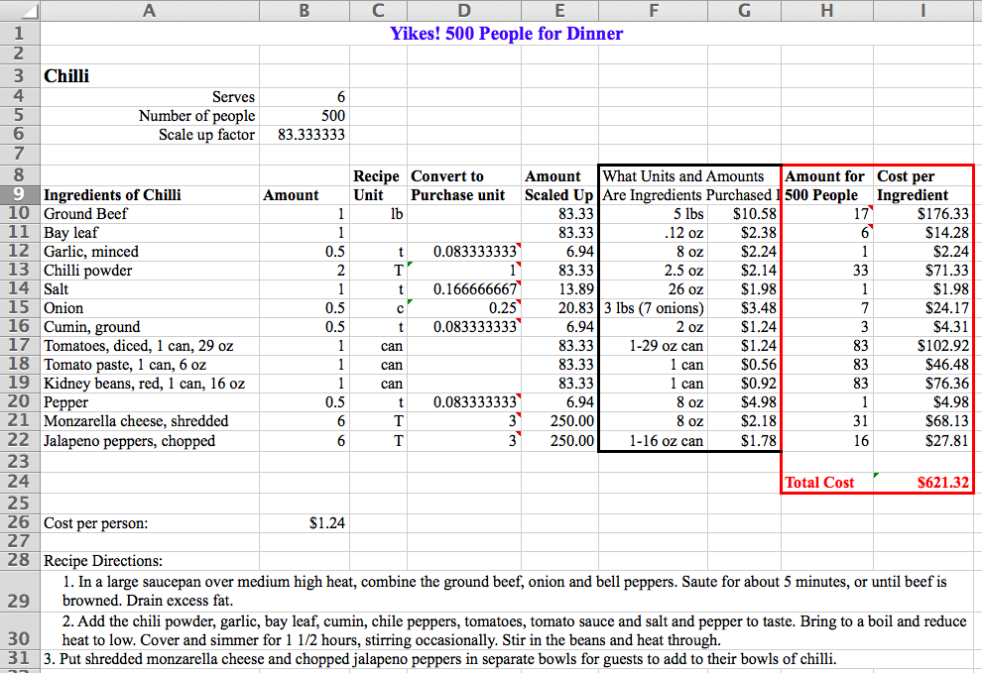

Spreadsheet with Formulas
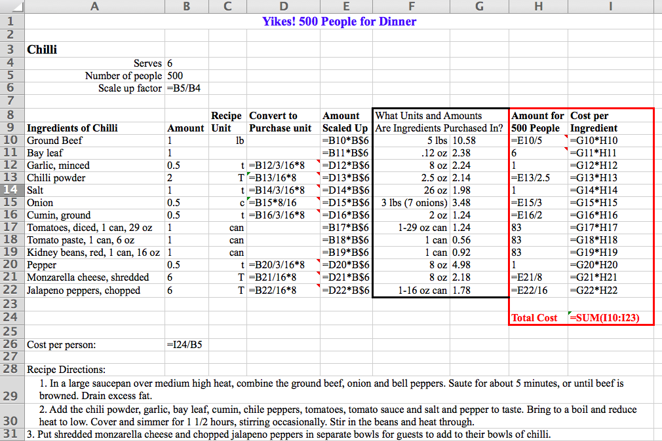

Spreadsheet with Comments
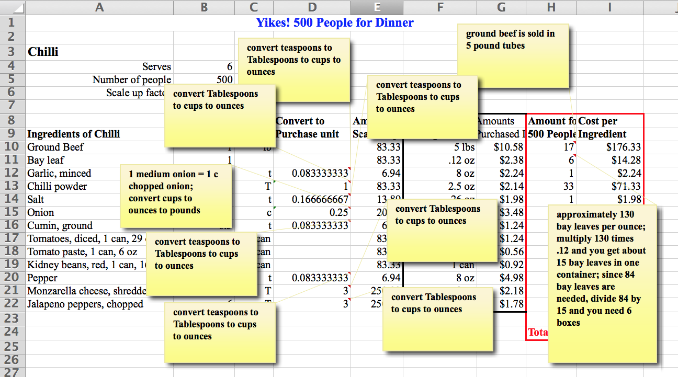

Class Activity Calculating the Price to Charge Guests

