What is the BEST Breakfast Cereal?

Standards:
Operations & Algebraic Thinking
- 4.OA.1 Interpret a multiplication equation as a comparison, e.g., interpret 35 = 5 × 7 as a statement that 35 is 5 times as many as 7 and 7 times as many as 5. Represent verbal statements of multiplicative comparisons as multiplication equations.
- 4.OA.2 Multiply or divide to solve word problems involving multiplicative comparison, e.g., by using drawings and equations with a symbol for the unknown number to represent the problem, distinguishing multiplicative comparison from additive comparison.¹
- 4.OA.3 Solve multistep word problems posed with whole numbers and having whole-number answers using the four operations, including problems in which remainders must be interpreted. Represent these problems using equations with a letter standing for the unknown quantity. Assess the reasonableness of answers using mental computation and estimation strategies including rounding.
Measurement & Data
- 4.MD.2 Use the four operations to solve word problems involving distances, intervals of time, liquid volumes, masses of objects, and money, including problems involving simple fractions or decimals, and problems that require expressing measurements given in a larger unit in terms of a smaller unit. Represent measurement quantities using diagrams such as number line diagrams that feature a measurement scale.

Learning Objectives:
- Students will use a spreadsheet to perform multiple calculations to determine the best cereal based on multiple factors.

Resources needed:
- Computer with Internet access
- Spreadsheet software such as Microsoft Excel
- Real Cereal, purchase cereal for students to taste

What is the BEST Breakfast Cereal?

Almost everyone eats breakfast cereal whether you eat it in the morning or later in the day. Have you noticed how many types of cereal there are in your local grocery story? There is a great variation in costs, how they are packaged, their taste, and nutritional value. Your teacher will divide the class into pairs to work on this project.

Project Tasks:

Let’s go to the grocery story:
- Each group will discuss and write down the names of 10 breakfast cereals that you like or have eaten before.
- Go to the grocery store to gather information and prices about those 10 cereals. If you cannot go to the grocery store, you can research this information on the Internet.
- Use the table below to record the cereal name, size of box (in ounces), and price.

 | Cereal Name | Size (in ounces) | Price

Using the spreadsheet:
- Add the data from your chart to a spreadsheet.
- Add another column called “Price in Cents/Ounce per oz”, another column called “Taste Index”, and another column called “Adjusted Worth per oz”.
- How would you calculate the cost of each cereal per ounce? Enter this formula into the cell for the first cereal under the “Price in Cents/Ounce per oz” column. The spreadsheet will display the result of the formula. Use the Fill Down feature to copy the formula down to display the cost per ounce for the other 9 cereals. Remember that the lower the prices per ounce are better.
- So how much do you like the taste this cereal? Your teacher will provide a small sample of each cereal. Assign each cereal a "taste index" which is a value from 1 to 5. A rating of 1 is "best taste". A rating of 5 is "worst taste". Record these indexes in your spreadsheet. This is your personal opinion for how much you like the taste of the cereal. Record this taste rating for each cereal on your spreadsheet in the “Taste Index” column. Remember that the lower the taste index numbers are better.

- In the cell for the first cereal under the “Adjusted Worth per oz” column, create a formula that adds the “Price in Cents/Ounce per oz” and “Taste Index”. Use the Fill Down feature to copy the formula down to display the adjusted worth for the other 9 cereals.

Here is a sample spreadsheet:
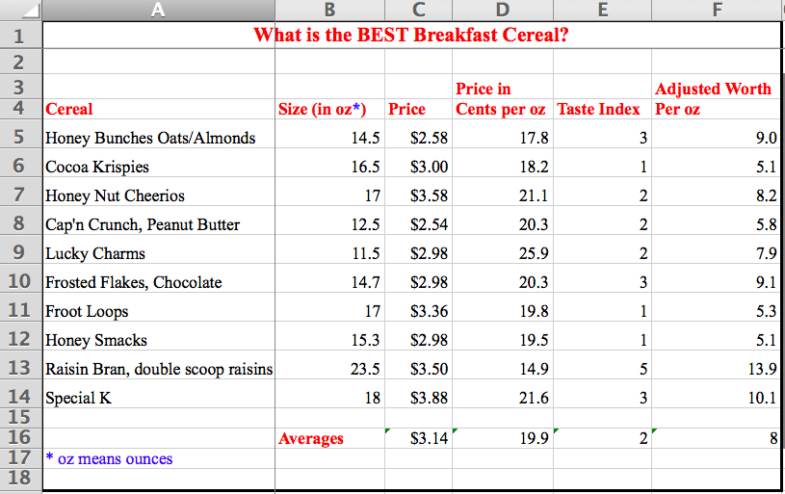

- Class Discussion: From your calculations, which is the best cereal or the cereal with the lowest Adjusted Worth? Is this the cereal that you thought would be the best cereal? Explain why or why not.

- Class Discussion: Are there other factors that may help to determine which is the best cereal? What might they be? Explain.

- Use the http://nutritiondata.self.com website to look up the Fullness Factor, Nutrition Data Factor, and Completeness Score for each cereal. The following explains these terms.
  - The Fullness Factor™ (FF) rates foods on a 0 to 5 scale that predicts the satiating effect of the food. Higher FF numbers indicate that a food is more filling or satisfying per calorie. Lower FF numbers suggest that a food will supply a lot of calories before you feel full. Therefore, foods with high FF numbers may support weight loss and foods with low FF numbers may support weight gain.
  - The ND (Nutrition Data) Rating scores foods on a 0 to 5 scale based on the FDA recommendations for a healthy diet. A higher ND Rating indicates that a food is more nutritious. The proprietary formula used to derive the ND Rating takes into account the nutrient density of the food (how many nutrients per calorie), how many different essential nutrients are present, the relative importance of the nutrients present, and the amount of nutrients that are frequently overconsumed, such as sodium, cholesterol, and saturated fat.
  - Completeness Score (range 1-100): Very few foods contain a complete array of essential nutrients; therefore, it's important to eat a variety of foods to fulfill our nutritional needs. This Nutrient Balance Indicator™ lets you see at a glance the nutritional strengths and weaknesses of a food, and can help you construct meals that are more nutritionally balanced.

Each spoke in the wheel represents a different nutrient. The spoke for dietary fiber is colored green, protein is blue, vitamins are purple, minerals are white, and yellow represents a group of commonly overconsumed nutrients—saturated fat, cholesterol, and sodium. The density of each nutrient is indicated by how far that spoke extends towards the edge of the graph. A Completeness Score™ between 0 and 100 summarizes how complete the food is with respect to 23 essential nutrients.

- Add the Fullness Factor, Nutrition Data Factor, and Completeness Score to your spreadsheet.

Here is a sample spreadsheet:
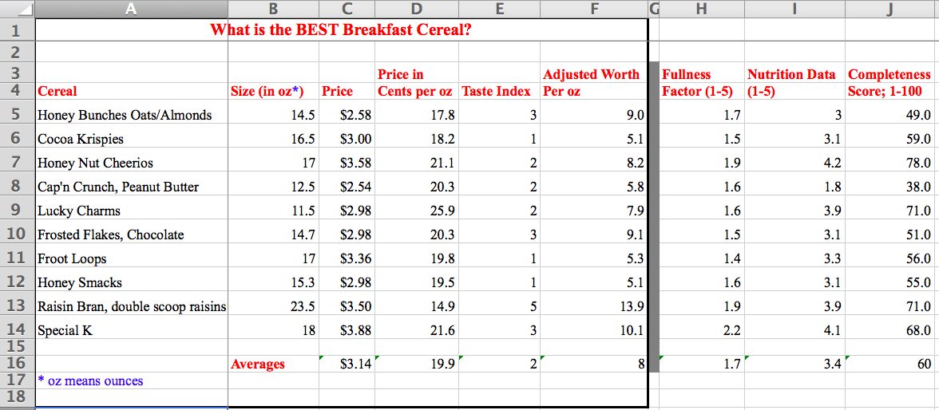

- Group Discussion: Write the answers to the following questions.
  - Which 3 cereals make you feel more full?
  - Which 3 cereals are the most nutritious?
  - Which 3 cereals have the highest Completeness Score?
  - Are the 3 cereals the same on the above questions? Explain.
  - Discuss the BEST cereal using the cost, taste, fullness, nutrition, and completeness of nutrition factors in your discussion.
- Class discussion:
  - Groups will present their findings and conclusions about the BEST cereal.
  - We will have a class discussion about the most important factors are in deciding what factors (cost, taste, fullness, nutrition, and completeness of nutrition factors are the most important in deciding on the BEST cereal.

Extensions:
- If you were working for a cereal company, and you were conducting a consumer survey of your cereal for the purpose of improving your cereal, what five questions would you ask?
- Add specific nutrition data to your spreadsheet to include fat, sugars, protein, and dietary fiber for each cereal.
  - Create a Nutrition Index that subtracts the good nutrition from the Bad nutrition. The lower numbers are best.
  - Create an Adjusted Value by adding the Taste Index and Nutrition Index.
  - Create an Adjusted Worth by adding Cost + Taste Index + Nutrition Index.
  - Which is a better indicator of the best cereal? Why?
  - Add a Calories column. How can this contribute to the Value or Worth of a cereal?

Here is a sample spreadsheet:
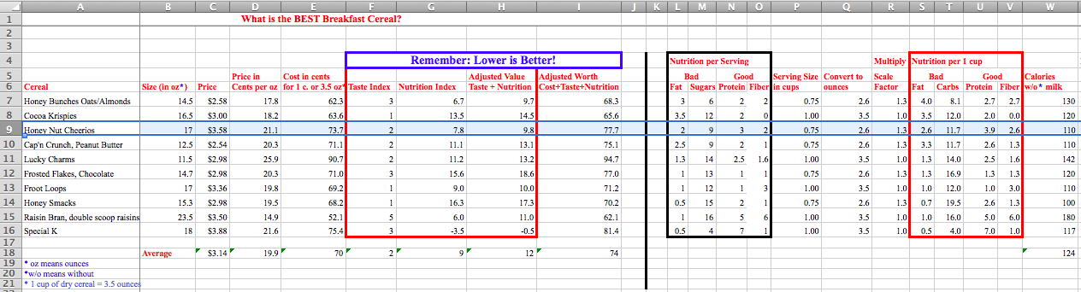

Scoring Rubric:

 | 1 Needs Much Revision | 2 Needs Some Revision | 3 Proficient | 4 Excellent
Followed Directions/  Neatness | Most tasks were not followed.  Spreadsheet is not organized and not logical. | Some tasks were not followed.  Spreadsheet is not organized and difficult to read. | All tasks were followed.  Spreadsheet is organized and readable. | All tasks were followed precisely.  Spreadsheet is visually organized, easy to read and follow your logic. All accomplished on the first attempt.
Spreadsheet/Calculations | Most formulas and calculations are not correct even with assistance from teacher. | Some formulas and calculations are not correct even with assistance from teacher. | All formulas and calculations are correct with some assistance from teacher. | All formulas and calculations are correct on the first attempt with no assistance.
Discussion about BEST Cereal | Students in groups did not decide upon the BEST cereal. Conclusions are very short, incomplete, and illogical. | Students in groups selected the BEST cereal and wrote conclusions using 1-2 of the 5 factors from this project. Conclusions may be incomplete or illogical. | Students in groups selected the BEST cereal and wrote adequate conclusions using at least 3 of the 5 factors from this project. | Students in groups selected the BEST cereal and wrote excellent, logical, conclusions using at least 4 of the 5 factors from this project.
Teamwork | Did not participate much in this project and focused little of your attention on the project. Did not work with your group. | Did not use all time well in this project and focused some of your attention on the project. Worked well with your group some of the time. | Used time well in this project and focused most of your attention on the project. Worked well with your group at all times. | Used time well in this project and focused full attention on the project. Worked well with your group at all times.

